EECS476 Mobile Robotics

PS9 Report

# 1. Example Use

$ roslaunch my_pcl_utils my_auto_find.launch

# 2. Grasp Points by Space

Use coordinate boundaries to limit the points that are to be grasped.

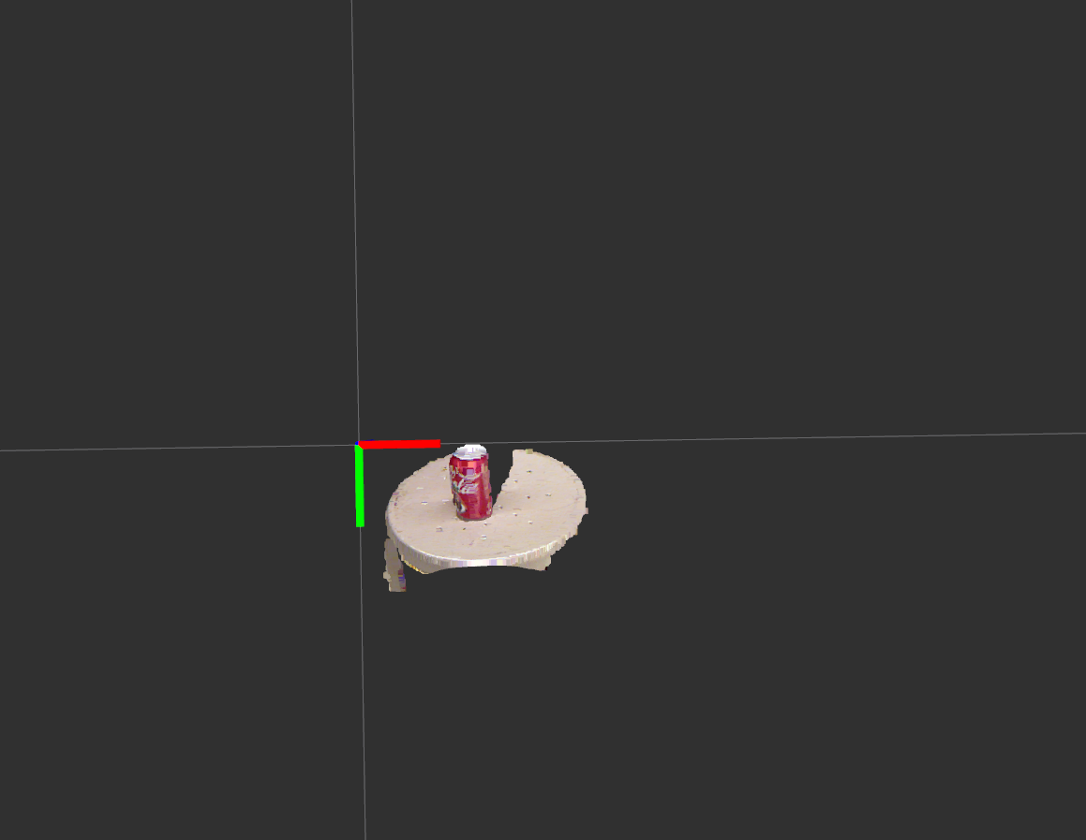

Fig. 1 Grasped points use space boundaries

# 3 Grasp Points by Color

Use rgb information contained in the points to detect the stool and the cokecan.

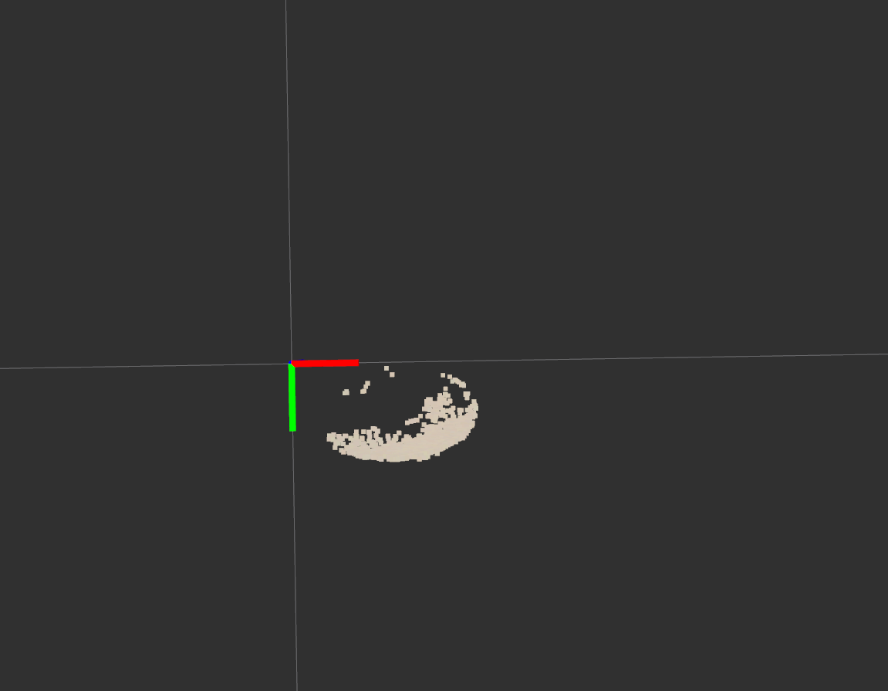

Fig. 2 Stool points

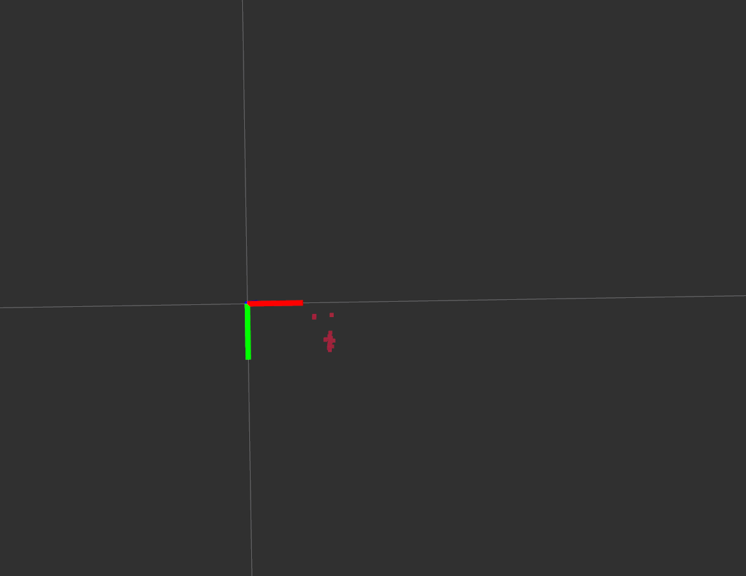

Fig. 3 Coke can points

# 4 Computation Results

(1) stool plane nomal

Based on the stool points grasped, we can calculate the stool plane’s normal by the function

PclUtils::fit_points_to_plane(Eigen::MatrixXf points_mat, Eigen::Vector3f &plane_normal, double &plane_dist).

The plane normal computed which can also be seen in the following picture is (0.276565, 0.906024, -0.320364).

(2) Transformation

In further, with the output value plane_normal and plane_dist and the following funciton

PclUtils::make_affine_from_plane_params(Eigen::Vector3f plane_normal, double plane_dist)

we can calculate the transformation matrix, which can be used in height computation.

(3) Compute the camera height to the can top

We can easily get the centroid of the coke can points. Generally, we can treat it as one point on the can top. With transformation, we can get the transformed the can top coordinate as below,

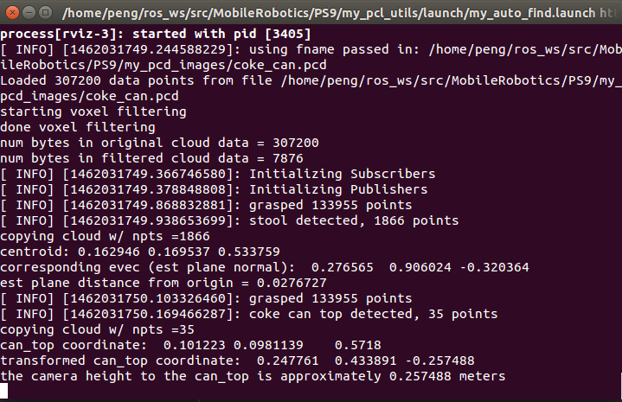

Fig. 4 Terminal output

that is, (0.247761, 0.433891, -0.257488).

Thus the camera (0,0,0) height is 0-(-0.257488) = 0.257488 meters.